**Postering Kit**

These PDFs can be used to make posters, which can then be affixed to all sorts of surfaces. Be sure that you know the legality of [wheatpasting](https://en.wikipedia.org/wiki/Flyposting) posters in your region and whatever rules might be specific to your site. Here are some [tips for not getting arrested](http://www.printwand.com/blog/how-to-run-a-wild-posting-campaign-without-getting-arrested), and here is a recipe for [wheatpaste](http://www.wikihow.com/Make-Wheat-Paste). The possibilities are endless!

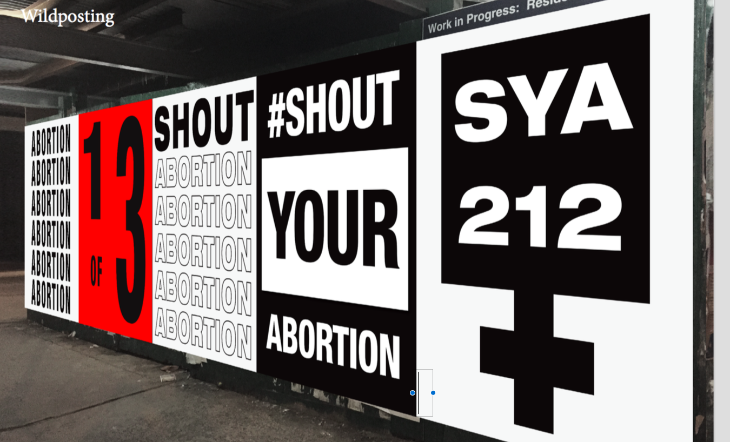

**Please email us pics of your SYA posters (if you want)--it would make us so happy to see what you come up with!** [**ShoutYourAbortion@gmail.com**](mailto:ShoutYourAbortion@gmail.com)